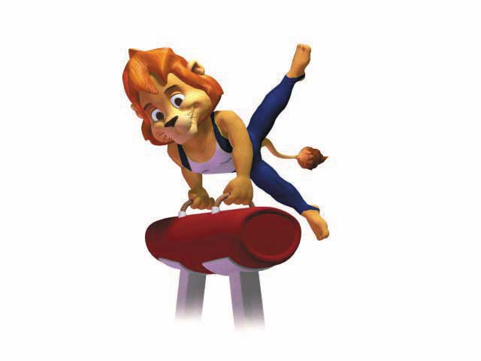
Gymnastics

Open Male Competition

Registered Countries: USA, Mexico, Hungary, Canada, Israel.

Open Female Competition

Registered Countries: USA, Hungary, Israel.

Juniors Boys Competition

Registered Countries: USA, Israel.

Juniors Girls Competition

Registered Countries: Azerbeijan, Canada, Mexico, Israel.

Venue:
- Hadar Yosef Multi Sport Hall.

Competition Director: Orna Shai

Open Male Competition

Place | Name | Country | Floor | Pommel Horse | Rings | Vaulting | Parallel  Bars | Horizontal  Bar | Total
1 | Goffman, Pavel | Israel | 9.05 | 8.5 | 9.35 | 9.0 | 8.8 | 9.3 | 54.0
2 | Macguire Rick | USA | 8.2 | 6.7 | 8.5 | 8.9 | 7.75 | 8.0 | 48.05
3 | Hamudis, Alex | Israel | 7.3 | 7.1 | 8.4 | 8.3 | 8.15 | 7.9 | 47.15

Open Female Competition

Place | Name | Country | Vaulting | Uneven  Bars | Beam | Floor | Total
1 | Morelli, Michal | Israel | 9.05 | 8.866 | 8.75 | 8.75 | 35.416
2 | Levy, Anat | Israel | 8.566 | 7.633 | 8.784 | 8.27 | 33.253
3 | Cohen, Hadas | Israel | 9.116 | 8.516 | 7.07 | 7.22 | 31.922

Gymnastics (cont.)

Juniors Boys Competition

Place | Name | Country | Floor | Pommel Horse | Rings | Vaulting | Parallel  Bars | Horizontal  Bar | Total
1 | Shaham, Noam | Israel | 8.35 | 3.9 | 8.55 | 9.1 | 6.65 | 6.6 | 43.15
2 | Shahar, Tal | Israel | 8.0 | 3.95 | 7.90 | 8.5 | 7.80 | 6.5 | 42.65
3 | Haharonovitz, Felix | Israel | 8.8 | 6.25 | 6.4 | 7.8 | 7.55 | 4.05 | 40.25

Juniors Girls Competition

Place | Name | Country | Vaulting | Uneven  Bars | Beam | Floor | Total
1 | Zarug, Stephi | Israel | 8.933 | 9.14 | 8.05 | 8.5 | 34.623
2 | Pop, Isist | Hungary | 8.666 | 7.64 | 8.05 | 8.5 | 32.856
3 | Cohen, Hen | Israel | 8.683 | 7.14 | 8.205 | 7.9 | 31.948

