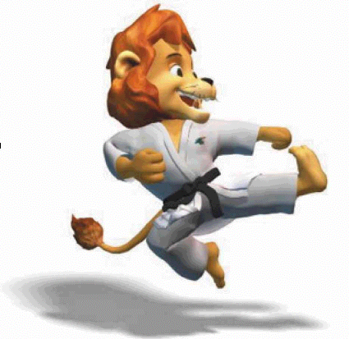
Karate

Open Male Competition

Registered Countries: Venezuela, Belarus, USA, Ukraine, Mexico, G. Britain, Germany, Georgia, France, Canada, Israel.

Open Female Competition

Registered Countries: Venezuela, USA, Mexico, Croatia, Canada, Israel.

Venue:
- Beit Dany Community Center, Tel Aviv.

Competition Director: Avi Bleier

Open Male Competition
Male Individual Kata

Place | Name | Country
1. | Sterenberg, Dov – Gold Medal | USA
2. | Merar, Arthur – Silver Medal | USA
3. | Zelinger, Boaz – Bronze Medal | Israel
3. | Arar, Jaleo – Bronze Medal | Israel

Male Team Kata

Place | Country
1. | USA – Gold Medal
2. | Venezuela – Silver Medal
3. | Russia – Bronze Medal

Male Individual Kumite
Category: -60 Kg.

Place | Name | Country
1. | Older, Gregory – Gold Medal | USA
2. | Friedman, Boris – Silver Medal | Israel
3. | Leiderman, Arthur – Bronze Medal | Russia
3. | Waistaviano, Enrique – Bronze Medal | Germany

Karate (cont.)
Category: -65 Kg.

Place | Name | Country
1. | Stenberg, Low – Gold Medal | USA
2. | Averslock, David – Silver Medal | USA
3. | Asido, David – Bronze Medal | Israel
3. | Bar, Tzaji – Bronze Medal | Israel

Category: -70 Kg.

Place | Name | Country
1. | Attia, Franck – Gold Medal | France
2. | K. David – Silver Medal | Georgia
3. | Kutz, Beny – Bronze Medal | Israel
3. | Shabtai, Alon – Bronze Medal | Israel

Category: -75 Kg.

Place | Name | Country
1. | Itai, Ben – Gold Medal | Israel
2. | Menashe, Micha – Silver Medal | Israel
3. | Older, Adam – Bronze Medal | USA
3. | Bachar, Dany – Bronze Medal | Israel

Category: -80 Kg.

Place | Name | Country
1. | Mirashvili, Mordechai – Gold Medal | USA
2. | Ruiz, Miguel – Silver Medal | Venezuela
3. | Izchiri, Ofer – Bronze Medal | Israel
3. | Abelsky, Solomon – Bronze Medal | Germany

Category: +80 Kg.

Place | Name | Country
1. | Aualshvili, Menashe – Gold Medal | Israel
2. | Bronshtein, Roman – Silver Medal | Israel
3. | Cohen, Brad – Bronze Medal | Canada
3. | Rovalov, Aleksey – Bronze Medal | Russia

Karate (cont.)

Category: Open

Place | Name | Country
1. | Bronshtein, Roman – Gold Medal | Israel
2. | Kosashvili, Zukas – Silver Medal | Georgia
3. | Attia, Patrick – Bronze Medal | France

Open Female Competition
Female Individual Kata

Place | Name | Country
1. | Sitt, Esther – Gold Medal | Mexico
2. | Arar, Soha – Silver Medal | Israel
3. | Bergman, Ophira – Bronze Medal | USA
3. | Brawn, Terri – Bronze Medal | USA

Female Team Kata

Place | Country
1. | Israel – Gold Medal
2. | USA – Silver Medal

Female Individual Kumite
Category: -60 Kg.

Place | Name | Country
1. | Nimbra, Baram – Gold Medal | Israel
2. | Guri, Vered – Silver Medal | Israel
3. | Green, Marian – Bronze Medal | Canada
3. | Belehsen, Ilanit – Bronze Medal | USA

Category: +60 Kg.

Place | Name | Country
1. | Bergman, Ophira – Gold Medal | USA
2. | Michaeli, Sarit – Silver Medal | Israel
3. | Heim, Sylvia – Bronze Medal | Croatia

Karate (cont.)

Category: Open

Place | Name | Country
1. | Baram, Nimra – Gold Medal | Israel
2. | Beleshem, Ilanit – Silver Medal | USA
3. | Heim, Sylvia – Bronze Medal | Croatia



